**Assignment 6**

Last name: Shah

First name: Sargam

UTA Id: 1001275800

Date: 11/13/2016

**Decision Tree and Linear Regression Analysis using R**

Dataset: Reading Skills

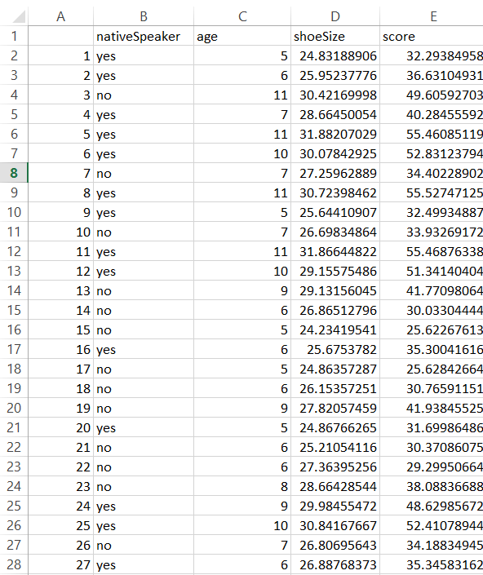

Decision Tree Classifier

Code:

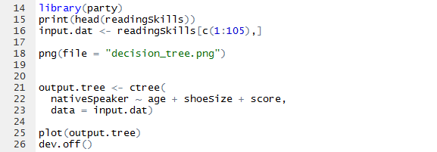

Output:

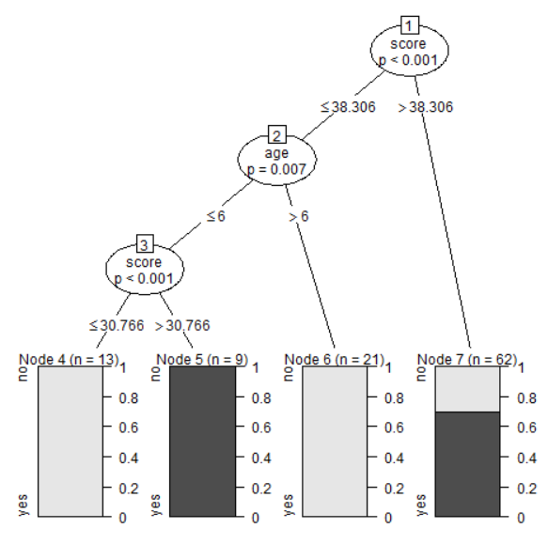

Testing of the decision tree:

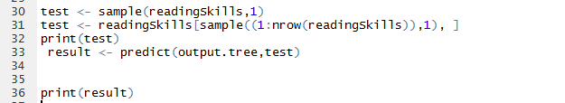

Output:

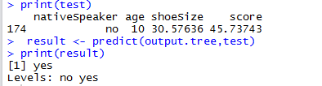

Linear regression Classifier

Code:

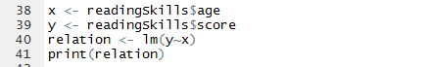

Output:

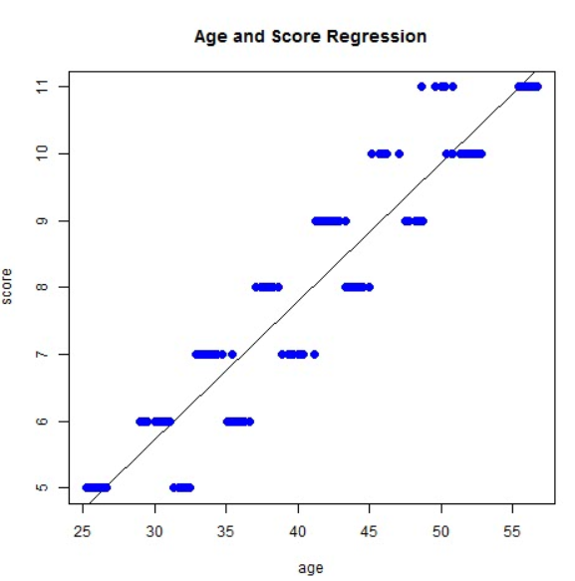

Test the linear regression model:

Code:



Output:

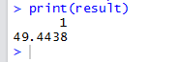

Attachments in the folder:

1. Output graphs for decision tree and linear model each
2. Dataset of reading skills
3. R code for the project